Question #1

Question #2

Question #3

Question #4

Question #5

Question # 6

Question # 7

Question #8

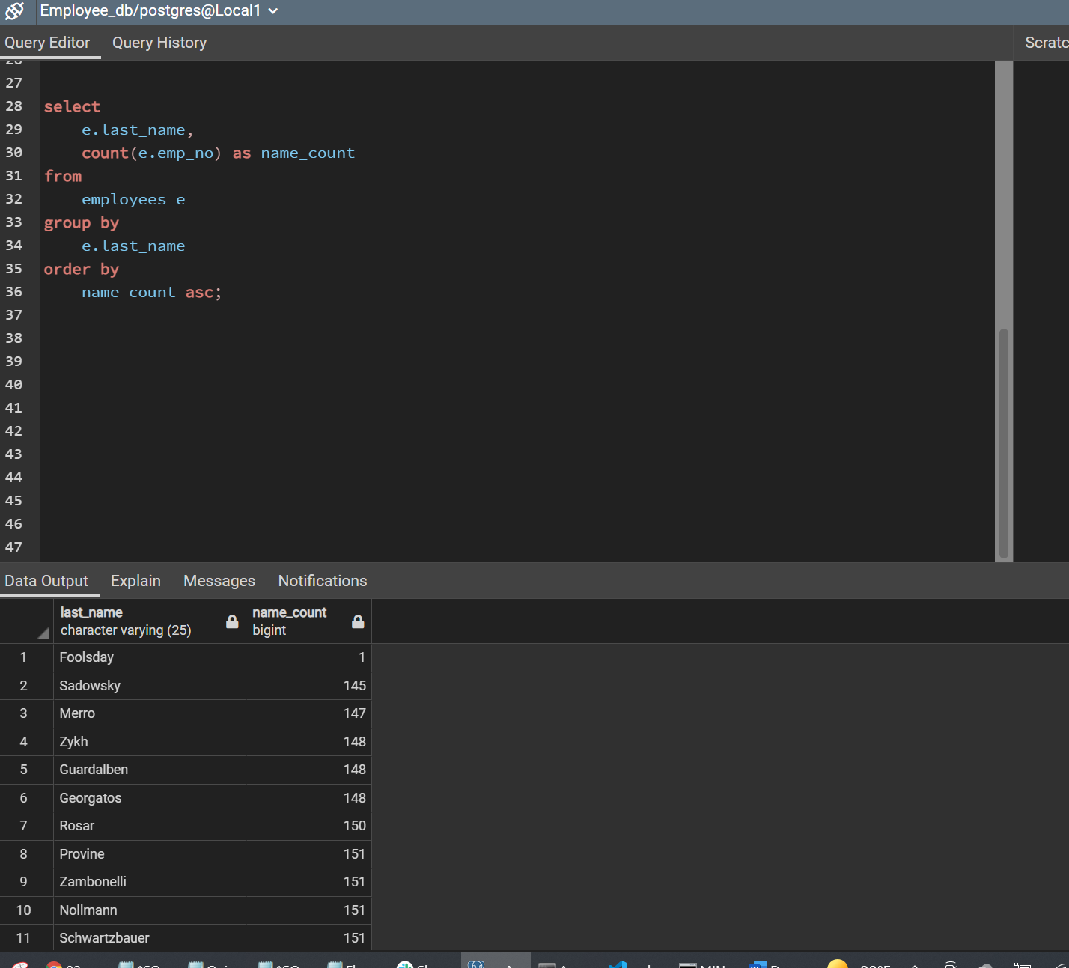

Bonus

